**Qlik Sense – Adventure Works DW 2014 neu - Internet Sales Visualization**

Data Model

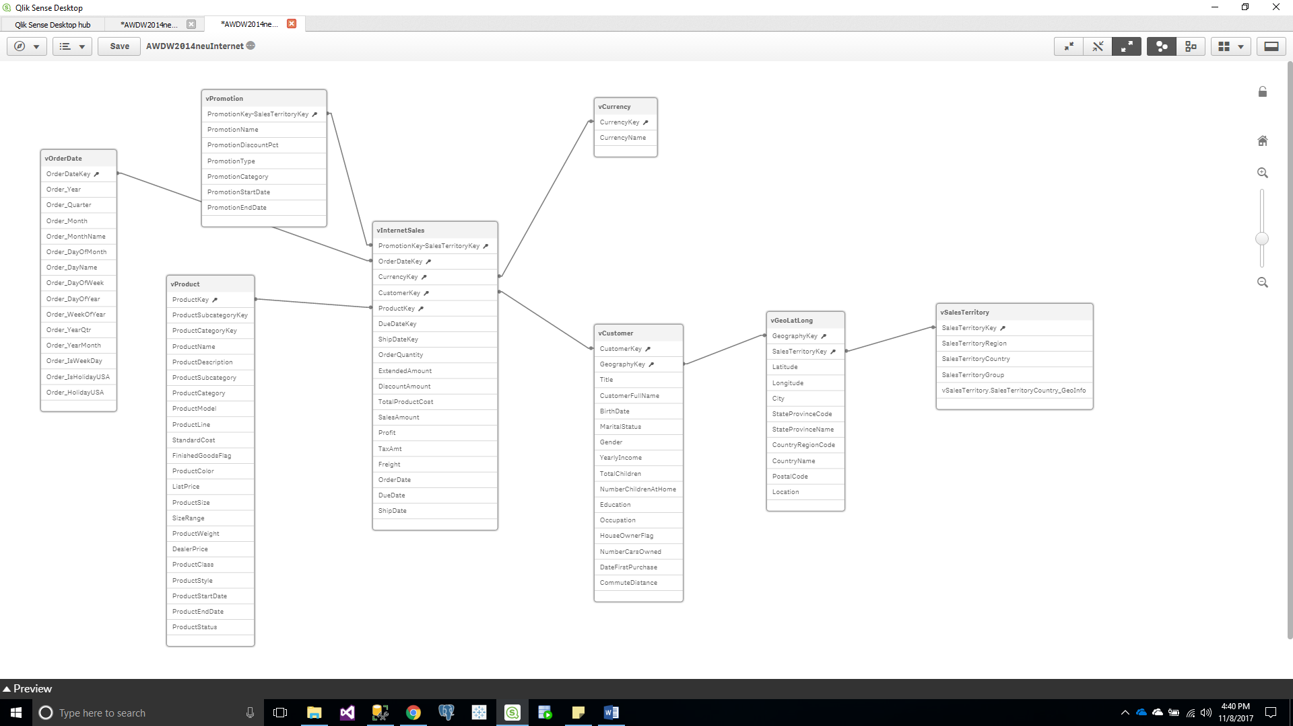

Visualization

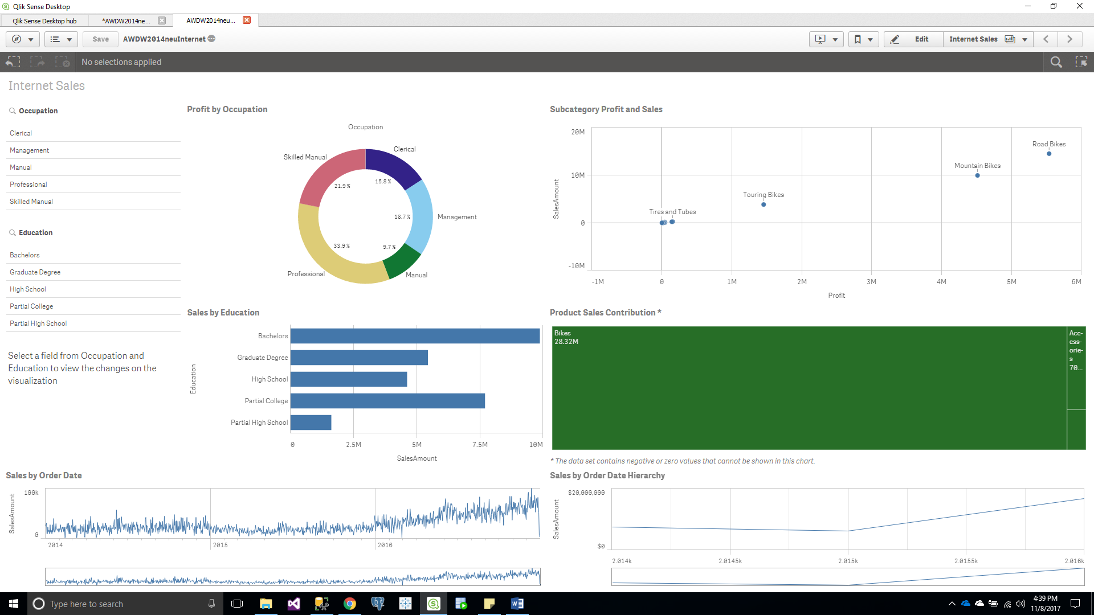

Load Script updated for Geo

